**Model Development Phase Template**

|  |  |
| --- | --- |
| Date | 06 JULY 2024 |
| Team ID | 739909 |
| Project Name | Unlocking Silent Signals: Decoding Body Language With Mediapipe |
| Maximum Marks | 4 Marks |

**Initial Model Training Code, Model Validation and Evaluation Report:**

The initial model training code will be showcased in the future through a screenshot. The model validation and evaluation report will include classification reports, accuracy, and confusion matrices for multiple models, presented through respective screenshots.

**Initial Model Training Code:**

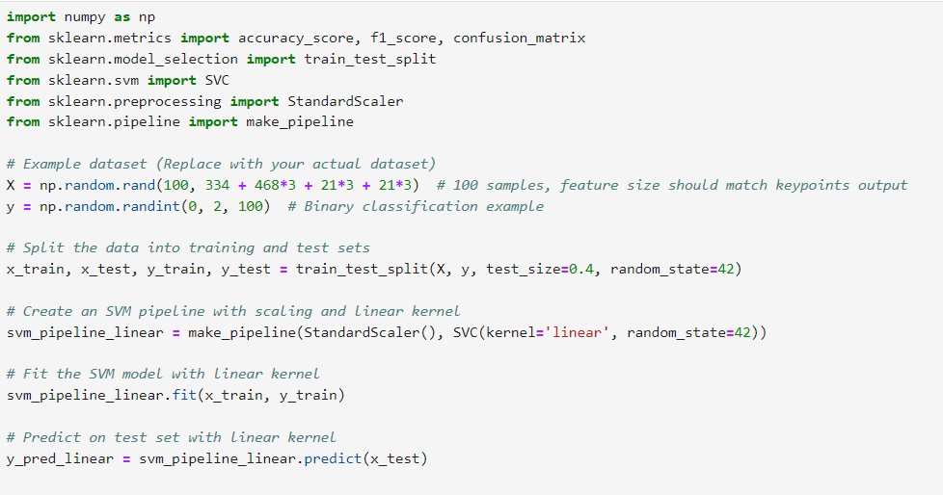

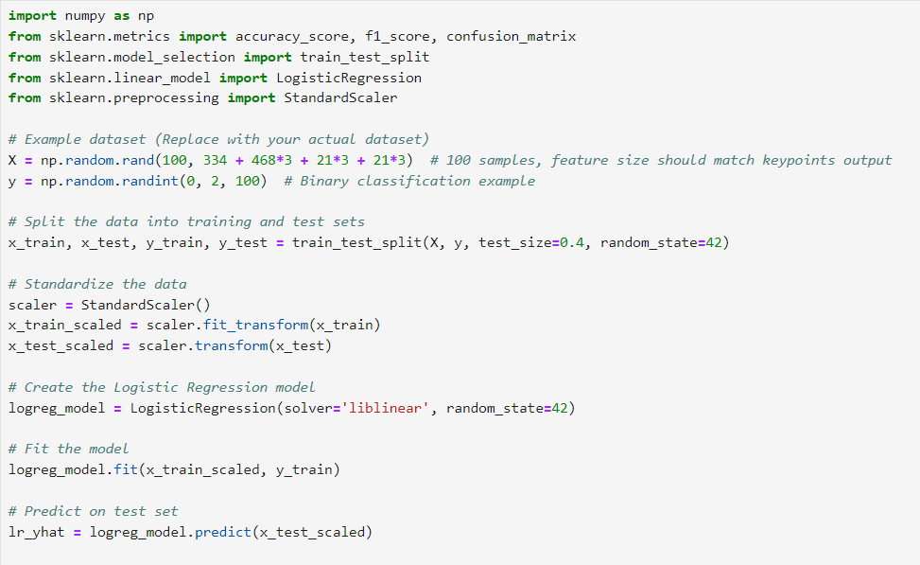

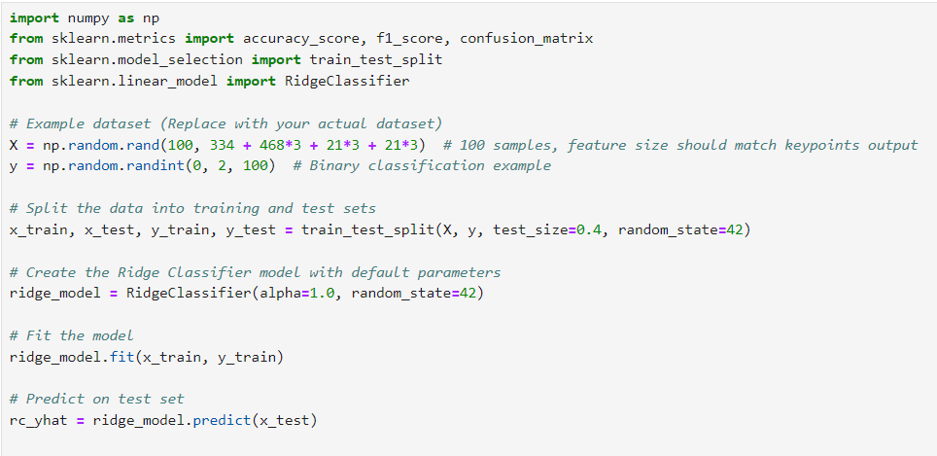

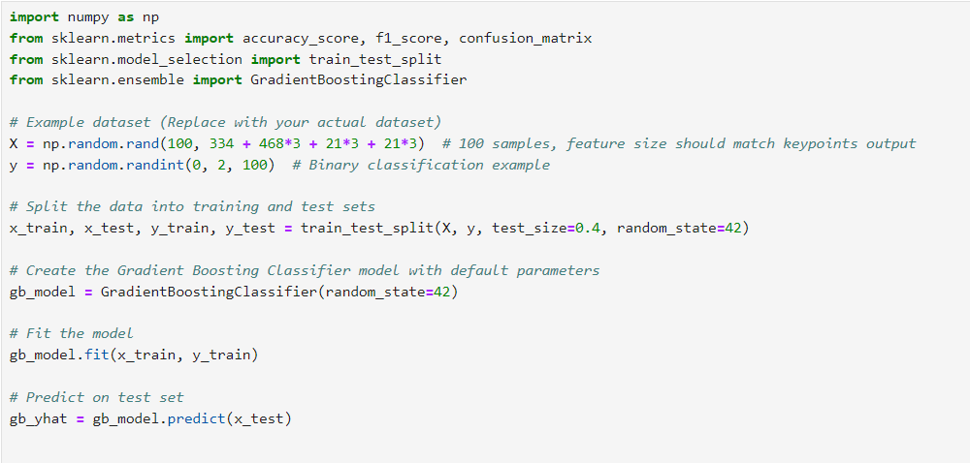

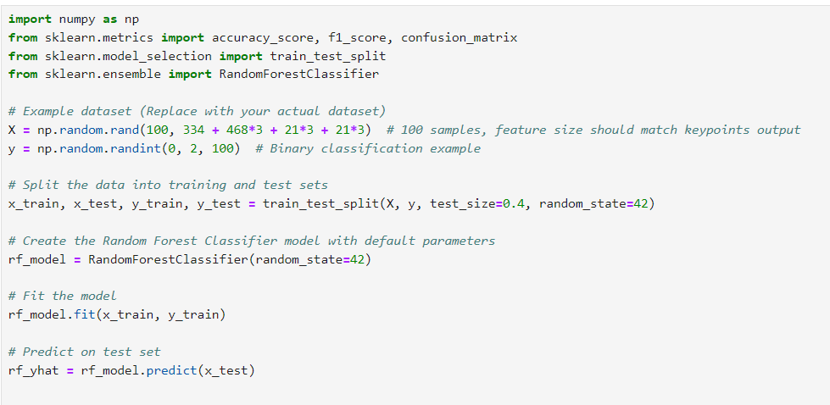

**Model Validation and Evaluation Report:**

|  |  |  |  |
| --- | --- | --- | --- |
| **Model** | **Classification**  **Report** | **F1 Score** | **Confusion**  **Matrix** |
| SVM |  | 27% |  |
| Logistic Regression |  | 37% |  |
| Ridge Classifier |  | 47% |  |
| Gradient Boosting Classifier |  | 41% |  |
| RandomForest Classifier |  | 74% |  |